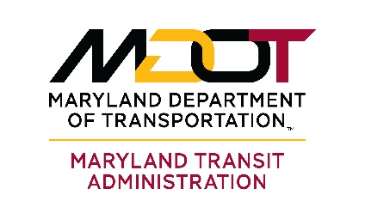
Bipartisan Infrastructure Law Compliance Confirmation for
Locally Operated Transit Systems (LOTS)

The November 2021 Bipartisan Infrastructure Law (P.L. 117-58) sets new requirements for transit agencies that receive FTA formula grant funds. Some requirements apply only to agencies that serve a Large Urbanized Area (UZA) with 200,000 or more in population.

- Applicability. Does your transit agency serve a Large UZA? (Large UZAs that are located within or partly in Maryland include Baltimore, Philadelphia, Washington, DC, and Aberdeen-Bel Air).

______ YES (Go to Question 3-7) ______ NO (Go to Question 2)

- Transit agencies serving Small UZAs and rural areas. You are required to develop your Public Transportation Agency Safety Plan (PTASP) in cooperation with frontline employees. FTA has not provided explicit guidance on what this means. Some ideas include:
  - Talk to employees about the PTASP (job briefings, initial onboarding, safety talks)
  - Distribute your PTASP to employees and ask for their feedback
  - Alert employees when PTASP has been updated and tell them what was changed
Please give a short description of how your PTASP was developed in cooperation with frontline employees.

Agencies serving Small UZAs and rural areas: After completing this question, please have the Accountable Executive sign and date this letter and submit it with your updated PTASP.

- Joint Labor-Management Safety Committees. Agencies serving Large UZAs must establish a Safety Committee with 50% agency management/50% frontline employee representation. This can be a newly-formed committee or an existing Safety Committee with adjusted membership. There is no requirement or guidance on how frequently the Safety Committee meets. Agencies serving large UZAs were required to establish their joint Safety Committee by July 31, 2022.

Have you established a joint agency management/frontline employee Safety Committee?

______ YES _____ NO

- How frequently does your Safety Committee meet?
______________________________________________________________________________

- Is there a written document establishing your Safety Committee and describing responsibilities? (If so, please give the name of the document and attach as an appendix to your PTASP)

______________________________________________________________________________
- Please name the positions represented on your agency’s Safety Committee (not names).

AGENCY MANAGEMENT REPRESENTATIVES FRONTLINE EMPLOYEE REPRESENTATIVES
___________________________________ ___________________________________
___________________________________ ___________________________________
___________________________________ ___________________________________
___________________________________ ___________________________________

- Your agency’s joint Safety Committee must approve your PTASP before it is presented to the Board of Directors or Equivalent Authority for final approval. Please describe the forum and date at which Committee approval took place.

______________________________________________________________________________

Agencies serving Large UZAs: After completing questions 3-7, please have the Accountable Executive sign and date this letter and submit it with your updated PTASP.

CONFIRMATION OF COMPLIANCE WITH 49 U.S.C. 5329(d)(1) and (d)(5)

I, _________________________________________, the Accountable Executive of
(Accountable Executive’s Name)

___________________________________________________________________,
(Agency Name)

confirm that the information included in this statement is true and accurate as of the
date below.

______________________________________ __________________________
NAME DATE

