Feelings Wheel: core emotions are at the center of the circle —often the easiest place to start. After choosing the most accurate core emotion, you can use your finger to identify the more specific emotions that you connect with on the outer edges of the circle.

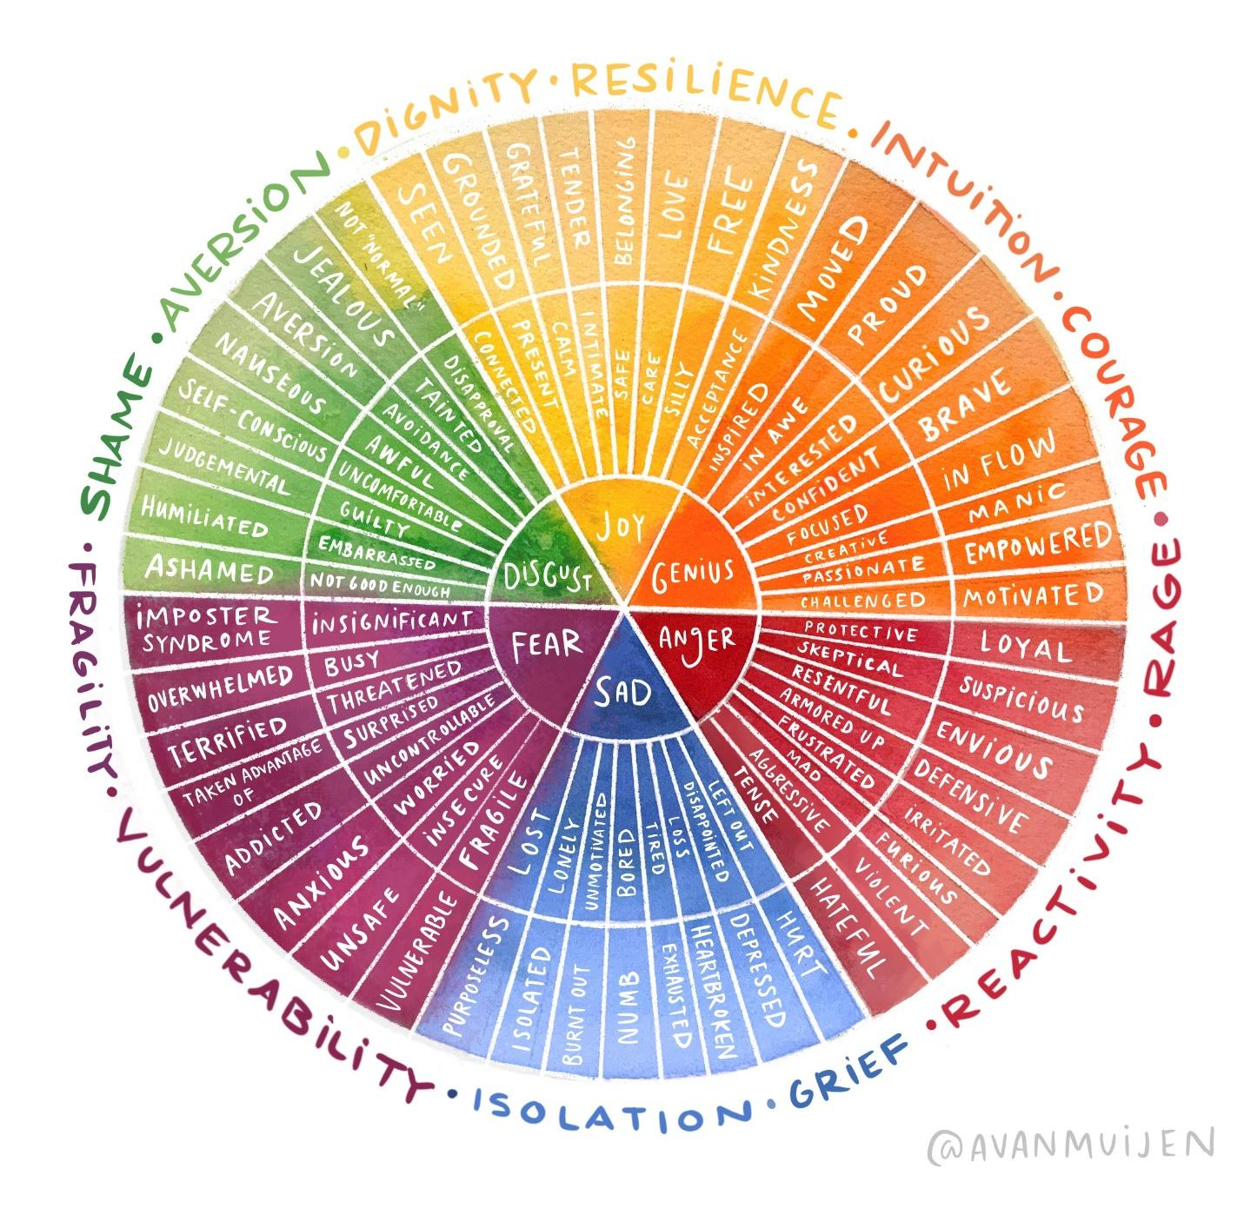

https://www.avanmuijen.com/watercolor-emotion-wheel

